JAVASCRIPT QUIZ GAME

A MINI PROJECT REPORT

Submitted by

“Group: G30”

Khushboo Jain - 2410993045
Ishleen Kaur - 2410993197

in partial fulfillment for the award of the degree of

BACHELEOR OF ENGINEERING

in

CSE-AI



CHITKARA UNIVERSITY

CHANDIGARH-PATIALA NATIONAL HIGHWAY
RAJPURA (PATIALA) PUNJAB-140401 (INDIA)

Table of Contents

Introduction

Problem Statement

Technical Details

Key Features

- Features or Pages we have

Project Highlights

Bonus Feature(optional)

Conclusion

References/Links used

Introduction

- Goal
It can serve multiple purposes:
- Learning: Help players familiarize themselves with key concepts, programming syntax, best practices, and the evolution of programming languages.
- Skill Improvement: Test players' understanding of coding languages, enabling them to identify areas where they may need improvement.
- Engagement: Provide a fun and interactive way for programmers, students, or enthusiasts to engage with the field of software development.
- Competition: Encourage friendly competition, either individually or in teams, to see who has the best knowledge of programming languages.
- Exploration of Languages: Introduce players to languages they may not be familiar with, expanding their knowledge base.
- Memory Reinforcement: Help solidify foundational programming knowledge, making it easier for players to recall details when writing code in real-world projects.

- Aim
The aim of this is to improve knowledge retention and briefly test a student’s level of comprehension regarding course. It also helps in the cognitive development as it enhances memory, problem solving skills, and critical thinking. Also helps in enhance understanding, promote learning, and test knowledge of coding concepts, syntax, and history while encouraging friendly competition and skill development. The game challenges players to identify key features of different languages, compare programming paradigms, and recall important terminology. By offering questions at varying levels of difficulty, it caters to both beginners and advanced coders, promoting learning and skill enhancement. Additionally, it fosters a sense of competition, motivating players to engage with programming in a fun, rewarding way.

- Some research for this project is done from various web development tutoring sites and channels.

Problem Statement

- The problem statement for a JavaScript quiz game revolves around creating an interactive, engaging, and educational tool to assess and improve users' knowledge of JavaScript concepts. With the growing demand for interactive learning platforms, there is a need for a dynamic quiz game that helps users, especially beginners and intermediate learners, test their understanding of JavaScript fundamentals, syntax, and common practices. The challenge lies in designing an intuitive, user-friendly interface that appeals to a wide range of learners while ensuring that the game’s functionality is robust and error-free.

- Key problems to address include the development of an adaptive quiz structure that provides real-time feedback, tracks user progress, and scales in difficulty. Additionally, it’s essential to ensure that the game is compatible across various devices, providing a responsive layout. Another challenge is creating a game that offers more than just basic questions but integrates problem-solving scenarios, allowing learners to deepen their JavaScript skills effectively.

- The problem statement for a JavaScript quiz game is centered around creating an engaging, interactive, and educational platform to help users, especially those learning JavaScript, improve their understanding of the language. With JavaScript being one of the most widely used programming languages, it is crucial to develop a tool that allows learners to test their knowledge in a dynamic and effective manner.

- The primary challenge lies in designing a game that is both user-friendly and educational, catering to varying skill levels from beginners to intermediate learners.The game must offer well-structured quizzes that cover key JavaScript concepts, including syntax, data structures, algorithms, and best practices. A major challenge is integrating real-time feedback to guide users towards correct solutions and explanations for incorrect answers. Additionally, the game needs to be responsive, ensuring compatibility across devices like desktops, tablets, and smartphones.

- The design should also allow for progression tracking, achievements, and difficulty scaling, enhancing user engagement while promoting continuous learning.

Technical Details

- HTML (HyperText Markup Language) for the basic structure (used as building block) of the game. HTML provides the foundational structure of a programming language quiz game. It organizes the content into sections such as questions, answers, and buttons. HTML defines the layout, including headings, paragraphs, and input forms, making the game accessible and interactive. By creating the skeleton of the page, HTML ensures that all elements, like the quiz questions and answer choices, are displayed correctly. It also enables navigation between different parts of the game, such as progressing through questions or displaying scores. Overall, HTML is essential for structuring the game's content and ensuring a seamless user experience.

- CSS (Cascading Style Sheet) for the designing and beautification of the game. It enhances the visual presentation of a programming language quiz game. It controls the styling of elements like fonts, colors, buttons, and backgrounds, ensuring the game is visually appealing and easy to navigate. CSS is responsible for making the game responsive, adjusting the layout for different screen sizes and devices. It also adds interactive effects, such as button hover states, smooth transitions, and animations, which make the game more engaging. By creating a polished and user-friendly interface, CSS plays a key role in improving the overall aesthetic and user experience of the quiz game.

- JS (JavaScript) for making the game working and fully functional.It provides the interactivity and dynamic functionality in a programming language quiz game. It handles the game logic, such as timing, score calculation, and tracking the player’s progress. JavaScript makes the game responsive to user input, allowing players to select answers, receive feedback, and move through questions without page reloads. It also controls animations, transitions, and other interactive elements, like changing the displayed content after each answer. By enabling real-time interactions and managing the game's flow, JavaScript is essential for turning a static quiz into a fully interactive and engaging experience for players.
Key Features

- User-friendly interface

Intuitive design for cognitive development through various kinds of questions related to the course. A user-friendly interface ensures that students can navigate the quiz game effortlessly. Intuitive design, clear visual hierarchy, and easily accessible buttons help reduce cognitive load, allowing students to focus on answering questions, enhancing learning and engagement.

- Gamified Learning Experience

Motivates students to actively participate in education. Gamification introduces elements like rewards, points, and challenges, making learning more engaging. It encourages active participation, turning education into a fun experience. Features like achievements, progress levels, and competition motivate students to dive deeper into the course material.

- Analytical Abilities

Helps students gather, organise questions. Organizing and analyzing quiz questions helps students enhance their critical thinking skills. Sorting, categorizing, and evaluating different question types teach students to approach problems logically, improving their decision-making and ability to break down complex concepts and information effectively.

- Quantitative Reasoning

Skills to analyse and interpret vast variety of questionarrie related to the course. Quantitative reasoning in a quiz game involves analyzing data and solving problems using logical thinking. Students apply mathematical concepts to interpret numerical information, helping them develop skills necessary for real-world problem-solving, data analysis, and critical interpretation of various quantitative scenarios.

Features or Pages we have

- Home page

- Login page

- Sign-up page

- Rate Us page

- Contact Us

- Feedback Section

- Clickable animated Different Cards with Different Quizzes

- Quiz Commencement page along with Timer

- Login or sign-up through:
        - Twitter
        - LinkedIn
        - Google
        - Facebook

- About us Section

- Team Lead and member LinkedIn Linked Details

- Connect with Us Section

- Privacy policy

- Terms and Conditions

Project Highlights

Upcoming slides include the relevant screenshots of our running project.


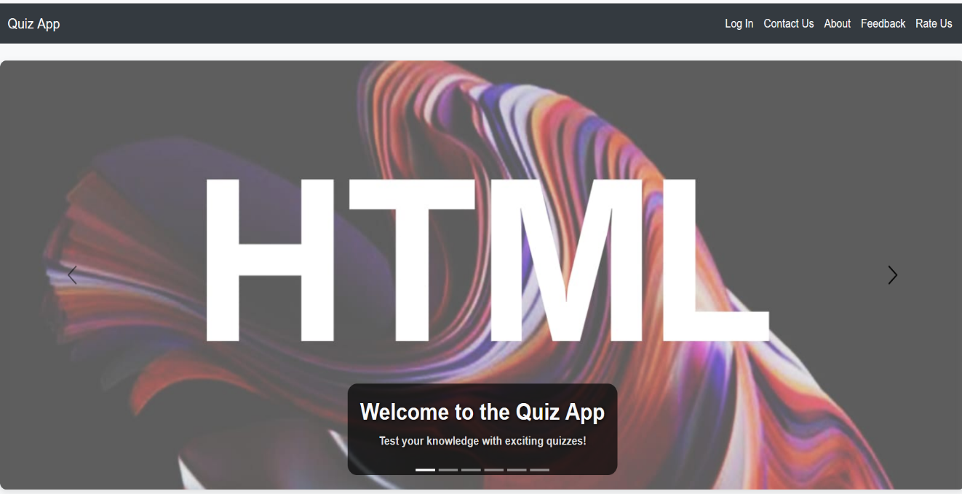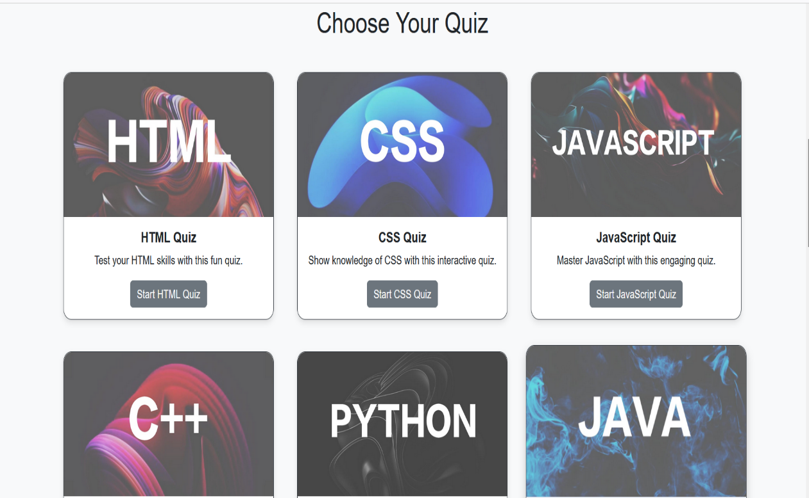

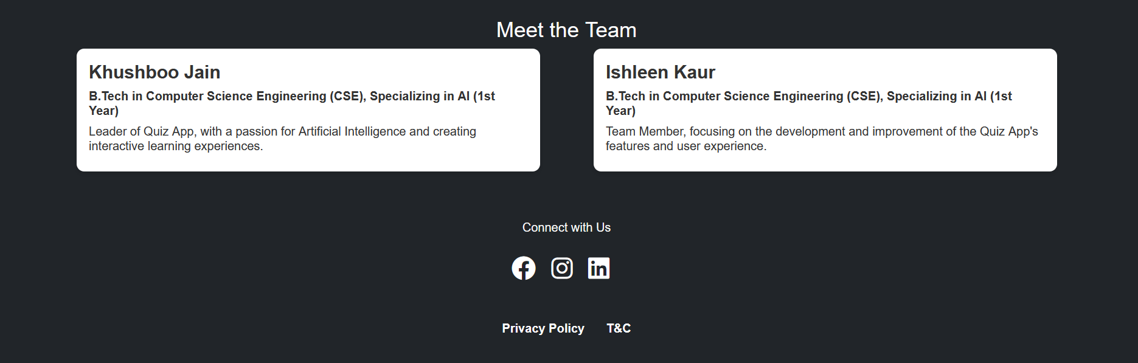
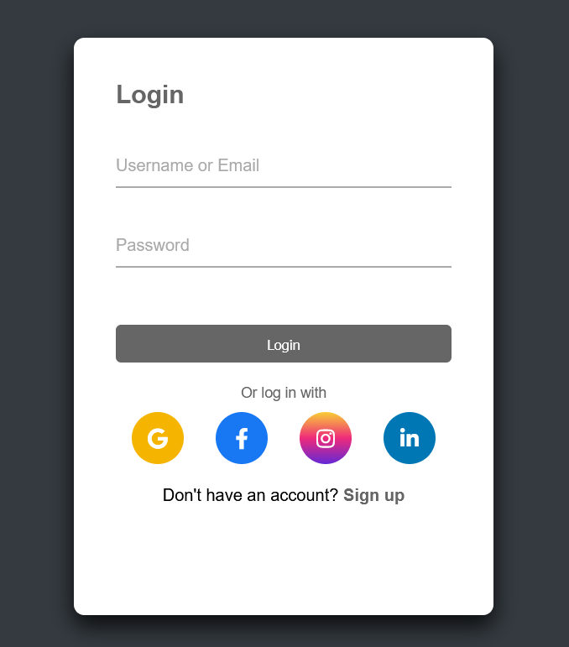

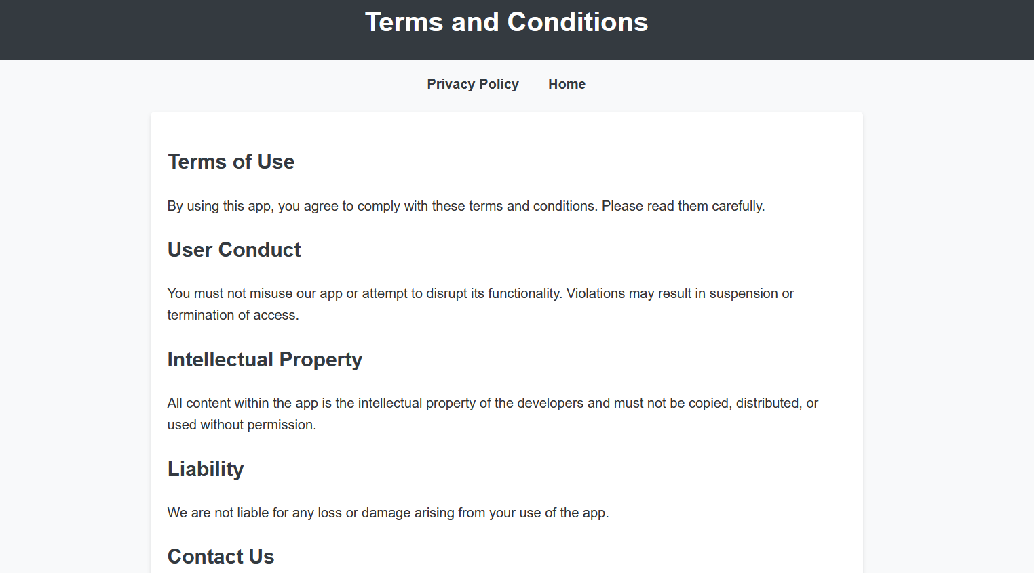
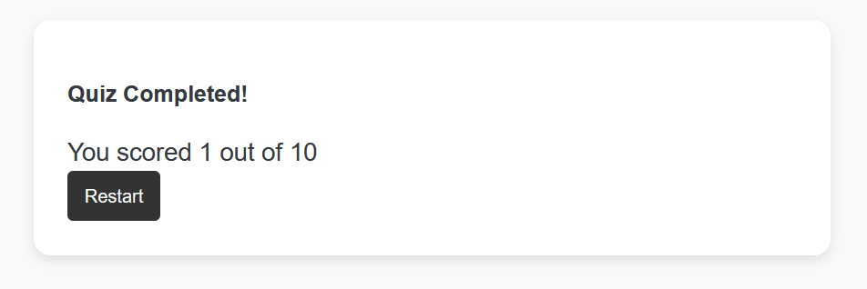
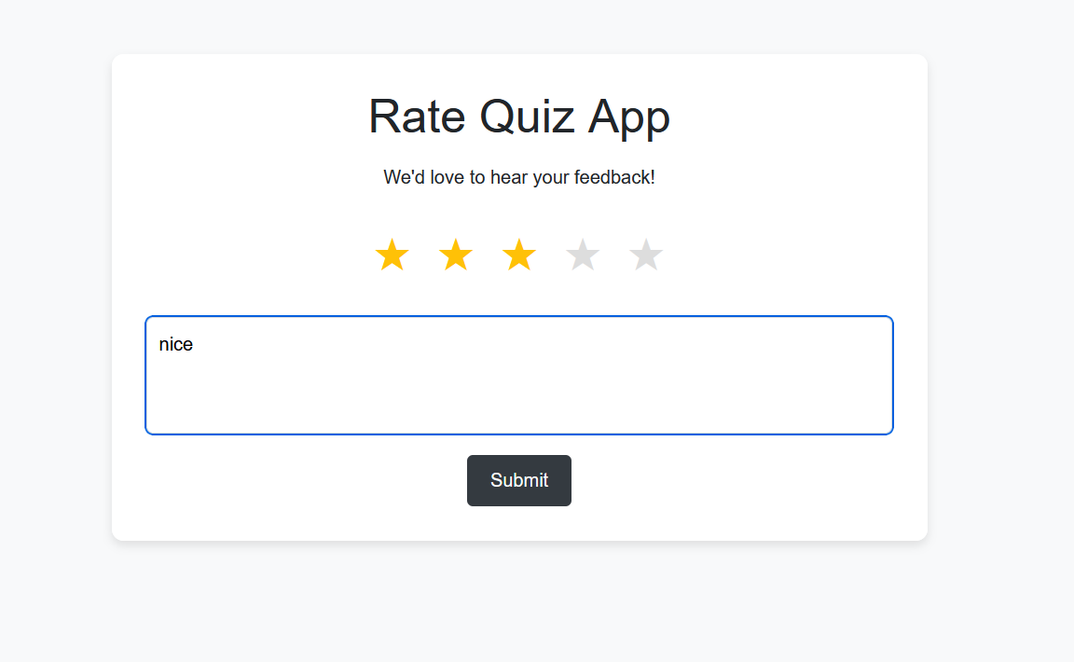
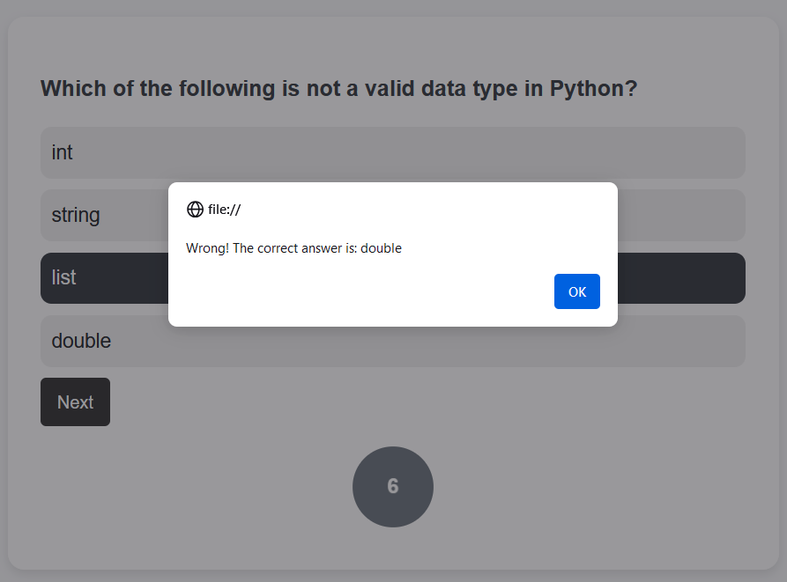

Bonus Feature (optional)

The next slide highlights the specific TIMER feature that is a bit distinct and innovative in your project.

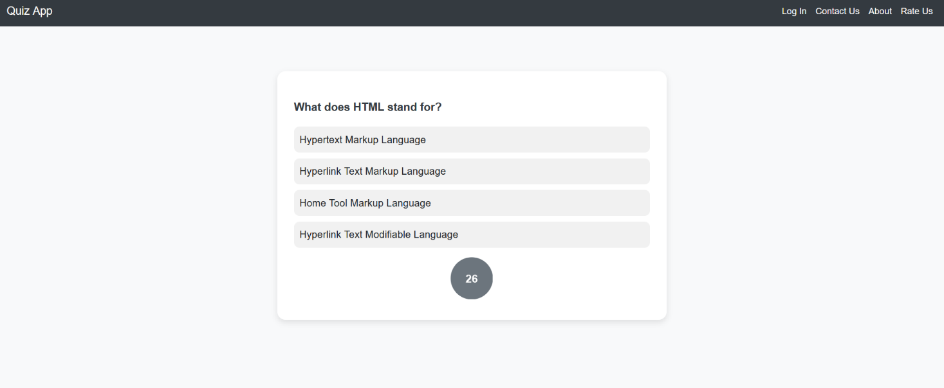



Conclusion

Following are the conclusions that can be aroused by the benefits of building this JavaScript enabled quiz game :-

Cognitive Development:
Enhances memory, problem-solving, and critical thinking by strengthening recall and encouraging logical, creative thinking.

Educational Benefits:
Simplifies complex concepts, expands vocabulary, and reinforces learning across subjects through interactive, engaging questions.

Social Skills:
Encourages communication, teamwork, and friendly competition, enhancing interpersonal skills and fostering stronger relationships.

Speed:
Improves mental agility, allowing quick thinking, decision-making, and enhanced cognitive processing under time pressure.

Creativity:
Stimulates imaginative thinking, creative problem-solving, and innovation through puzzles, riddles, and open-ended questions.

Attention and Concentration:
Enhances focus and concentration, improving academic performance and mental endurance through engaging gameplay.

Screen-Free Time:
Promotes offline learning and social interaction, offering a healthy balance between screen time and physical engagement.

References/Links used

- References used in the project are:-

- Sir Pavan Ambulkar’s provided course notes
- W3Schools website
- Several YouTube channels like:-
CodeWithHarry
ApnaCollege



